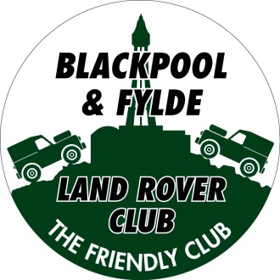
Club Clothing

Classic polo - £12.00
Sizes: XS to 6XL
Colours: Black, French Navy, Hot Pink, Bottle Green, Heather Grey, Maroon, Charcoal, Kelly Green, Navy, Orange, Purple, Red, Royal Blue, Sapphire Blue, Sky Blue, White, Yellow
Classic Hoodie - £20.00
Sizes: XS to 6XL
Colours: Black, Bottle Green, Brown, Charcoal, Heather Grey, Hot Pink, Jade, Kelly Green, Maroon, Navy, Military Green, Olive, Orange, Pink, Purple, Red, Royal Blue, Sapphire Blue, Sky Blue, Violet, White, Yellow
Classic Fleece - £20.00
Sizes: XS to 6XL
Colours: Black, Bottle Green, Charcoal, Maroon, Navy, Red, Royal Blue
Ladies Classic Fleece - £20.00
Sizes: XS to 4XL
Colours: Black, Navy, Red, Royal Blue
SIZE GUIDE
Size | To fit chest | Size | To fit chest
XS | 36” – 38” | S | 38” – 40”
M | 40” – 42” | L | 42” – 44”
XL | 44” – 46” | 2XL | 46”- 48”
3XL | 50” – 52” | 4XL | 52” – 54”
5XL | 54” – 56” | 6XL | 58” – 60”
Please note that the Ladies Fleeces are smaller – we would recommend that you order a size larger than you would usually buy
SPECIAL OFFER - Buy a hoodie or fleece and a polo shirt for £30.00

CLOTHING ORDER FORM

NAME
ADDRESS

TELEPHONE NUMBER

Item | Colour | Size | Quantity | Price
 |  |  | Total

Cash on Collection

